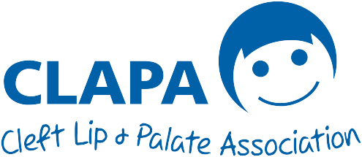

[Date]

Dear [name of teacher or school contact],

**An informational letter from CLAPA regarding cleft lip and palate**

**Re: Secondary School Transition for [child’s name]**

Here at The Cleft Lip and Palate Association (CLAPA) we provide information and support to families, adults, children and young people born with a cleft from across the UK. [Child’s name] was born with a [type of cleft, e.g. ‘cleft lip’] and will be joining you in [month child is starting school]. Therefore, we thought it would be useful to offer some support and guidance on the specific challenges and additional needs that may arise for a young person born with a cleft at school.

While many people born with a cleft report that they had a wonderful time in school, it can also be the peak age for teasing and name-calling. For those born with a difference like cleft which can cause them to look or sound different to their peers, this can be especially difficult.

**Key Concerns**

* The cleft treatment pathway is 20 years long. Young people may need **extra time off for operations, treatment and other essential appointments**. They may be more vulnerable and in need of support at these times, both academically and emotionally. They may be unfairly impacted by attendance awards and policies.
* Those with a visible difference like a cleft scar or noticeably different speech can face challenges that have a big **impact on self-esteem and mental wellbeing**, particularly during school years. [1]
* Young people born with a cleft may be a target for teasing or bullying. Even well-meaning questions from other young people about their cleft may be upsetting if handled insensitively.

**Recommendations**

For young people born with a cleft to thrive at this new stage of their education, it is vital that they have stability and a support system they can rely on. In our work with families and young people, we have found that the primary-secondary transition is a period when more acute needs can develop and, as a charity, we want to support schools to ensure that young people will thrive and reach their full academic potential.

Listed below are some suggested questions that you may want to consider discussing with the family, prior to their child starting at your school:

*1. How much does their child want people to know about their cleft journey?*

*2. Is there any language that their child does/doesn’t like when referring to a cleft lip and/or palate?*

*3. What should school staff say or do if another pupil makes a comment or asks a question?*

*4. How would the child like the school to support them as they transition to their new school?*

*5. Does the child have any speech/hearing difficulties that the school should be aware of? If so, how will the school support with this?*

**Additional Resources**

Attached to this letter is a helpful guide discussing ways to support young people born with a cleft at school.There are also some great resources available on the CLAPA website (**clapa.com**/**school**) and Changing Faces website (changingfaces.org.uk) that can provide more information about supporting a child born with a cleft.

If you would like any more information about cleft lip and palate or would like to arrange an awareness-raising presentation at your school, please feel free to contact CLAPA on [info@clapa.com](mailto:info@clapa.com).

Yours Sincerely,

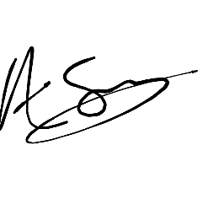

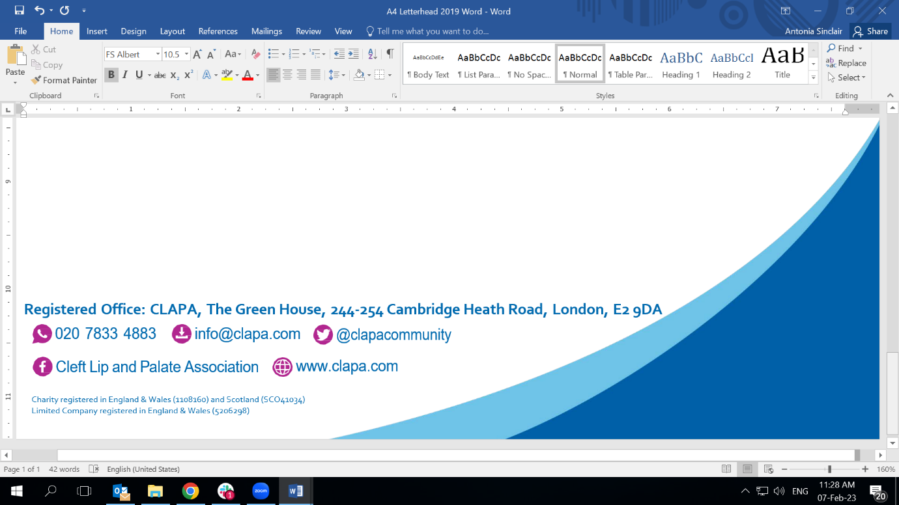

**Antonia Sinclair**

Community Engagement Coordinator

1. In a 2015 study of 16-year-olds born with a cleft, 42% reported bullying at least daily, 50% reported sadness, 31% depression, and 26.3% felt ‘marked for life’.